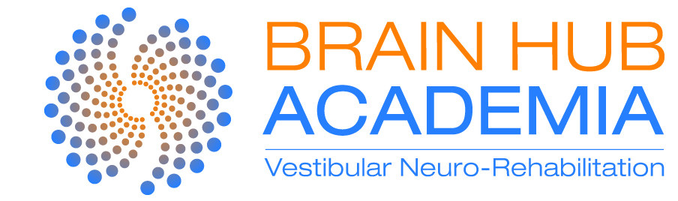

Managing the Dizziness Patient
~ a Vestibular Neuro-Rehabilitation Approach

ROME, Italy

Online lectures (pre-recorded with Italian subtitles - released Friday 9th September)
3+ hours of content

Introduction
- We explore the prevalence and impact dizziness conditions have on the community and our patients

Neurophysiology of the Vestibular System
- the evolutionary and neurodevelopment aspect of the vestibular system and its importance with children
- the anatomy and connections of the peripheral vestibular system
- the anatomy and connections of the central vestibular system

Vestibular Conditions
- We’ll cover the most common peripheral and central condition that we’ll present to the clinic. You will be across the main signs and symptoms, so you can quickly identify the condition underlying their symptoms, including red flags for medical referral

Dizziness History Taking
- There are many clues in a patient’s history that will guide you to make the correct next step.
- Learn a concise and efficient set of questions to ask a patient so you can narrow down the potential vestibular conditions.

SATURDAY 24th September

8:30 am - 9:00 am Registration

9:00 am – 9:30 am Q+A
- A quick revision of the online material
- Q+A from the audience on the online material

9:30 – 11:00 Cervicogenic Dizziness
- pathophysiology of cervical dysfunction and whiplash
- assessing and managing cervical joint position and proprioception (practical)

11:00 am – 11:20 am Morning coffee break

11:20 – 1:00 pm The Vestibular Examination – Balance and Gait
- understating the balance and gait system
- the main balance and gait assessments, including standardised tests (practical)

1:00 – 2:30 pm Lunch

2:30 pm – 4:00 pm The Vestibular Examination – Vestibulo-Ocular Reflex (VOR)
- understanding the VOR and its purpose
- extensive protocol of assessing the VOR, from reflexogenic and behavioural aspects (practical)

4:00 pm – 4:20 pm Afternoon coffee break

4:20 am – 6:00 pm The Vestibular Examination – Oculomotor
- how to differentiate between peripheral and central vestibular conditions
- visual pursuit and saccade eye movements
- nystagmus (spontaneous and gaze-evoked) - how to detect nystagmus and its clinical significance (practical)

SUNDAY 25th September

9:00 am – 10:00 am Summary and continued
- summary of Day 1
- continuation of Day 1 practicals

10:00 am – 11:10 pm BPPV I
- BPPV pathophysiology and its variants
- How to assess and manage BPPV and its variants (practical)

11:10 am – 11:30 am Morning coffee break

11:30 am – 12:30 pm BPPV II
- Continued (practical)

12:30pm – 2:00 pm Vestibular Rehabilitation Therapy

- You will be able to successfully integrate the information you have acquired from the history and physical examination into a tailored rehabilitation program specific to the patient’s findings.
- When to apply a vestibular, oculomotor or balance component to a therapy program
- Learn how to identify and manage a patient’s ‘intolerance’ to therapy

